UL only 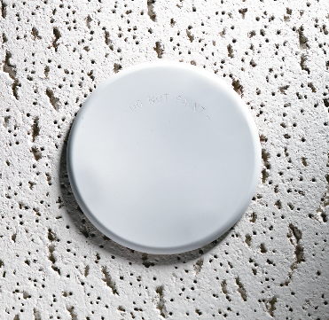

Engineering Specification

Model G5-56 Concealed Pendent Sprinkler

Flat concealed pendent sprinklers shall be [cULus Listed quick response] [FM Approved standard response] sprinklers for light and ordinary hazard applications in accordance with [NFPA 13 (year)] [FM Data Sheet (D.S. Number)]. Concealed pendent sprinklers shall be low profile, having a maximum installation dimension of 2-1/4” (57 mm) at full cover plate adjustment. And materials of construction shall be for interior, non-corrosive environments.

Sprinkler to be of bronze frame construction with drop down deflector and [165 °F (74 °C)] [212 °F (100 °C)] fusible solder link assembly. Water seal construction shall utilize Belleville spring seal coated with Teflon film on both sides. Flat cover plate assembly construction shall consist of brass cover plate attached to copper alloy skirt using [135 °F (57 °C)] [165 °F (74 °C)] ordinary temperature classification solder. Cover plate shall attach to sprinkler cup assembly by a threaded engagement providing ¾” (19 mm) of cover plate adjustment. Secure engagement of the cover plate to the sprinkler cup will ensure that the drop down deflector drops below the ceiling membrane at the proper distance for proper distribution. Cover plate design shall be [Plain (solid)] [Perforated] [Special Finish (specify)].

Concealed pendent sprinkler shall have a nominal K-factor of 5.6 (80) and have ½” NPT (R1/2) thread. A secure, factory installed protective cap shall be provided and shall be capable of preventing paint, joint compound, and other foreign matter from getting between and into the sprinkler cup assembly. These protective caps are to be removed once the sprinkler system is ready to be placed in service.

Flat quick response concealed pendent sprinklers to be Reliable Model G5-56 (RA3415). Refer to Reliable Bulletin 034.